**SQL Server**

**Assignment 2**

A Nageswar Rao

**2. create a table with name: Employee Details with following columns**

**-- EMP_ID with integer datatype, notnull, primary key and auto incremented**

**-- FIRST_NAME:varchar it should not be null , LAST_NAME: varchar , SALARY: money , JOINING_DATE: date , DEPARTMENT:varchar, AGE: integer age should not less that 21**

CREATE TABLE EMPLOYEE_DETAIL(

EMP_ID INTEGER NOT NULL,

FIRST_NAME VARCHAR(20),

LAST_NAME VARCHAR (20),

SALARY INTEGER,

JOINING_DATE DATE,

DEPARTMENT VARCHAR (50),

AGE INTEGER CHECK (Age >= 21),

CONSTRAINT EMPID_PK PRIMARY KEY (EMP_ID));



**3. Insert following data into table: EmployeeDetails**

**--EMP_ID FIRST_NAME LAST_NAME SALARYJOINING_DATE DEPARTMENT AGE**

**--1 Monika Arora 100000 2015-02-20 HR 25**

**--2 Verma 80000 2018-06-11 Admin 29**

**--3 Vishal Singhal 300000 2012-02-20 HR 30**

**--4 Amitabh Singh 500000 2009-02-20 Admin 22**

**--5 Vivek Bhati 500000 2017-06-11 Admin 55**

**--6 Vipul Diwan 200000 2017-06-11 Account 43**

**--7 Satish Kumar 75000 2018-01-20 Account 27**

**--8 Geetika Chauhan 90000 2020-04-11 Admin 50**

**--9 Harry null 110000 2007-06-11 Admin 50**

**--**

INSERT ALL

INTO EMPLOYEE_DETAIL (Emp_ID,First_Name,Last_Name,Salary,Joining_date,Department,Age) VALUES (1,'Monica','NULL',80000, To_date('2018.06.11','yyyy.mm.dd'),'Admin',29)

INTO EMPLOYEE_DETAIL (Emp_ID,First_Name,Last_Name,Salary,Joining_date,Department,Age) VALUES (2,'Verma','NULL',80000, To_date('2018.06.11','yyyy.mm.dd'),'Admin',29)

INTO EMPLOYEE_DETAIL(Emp_ID,First_Name,Last_Name,Salary,Joining_date,Department,Age) VALUES (3,'Vishal','Singhal',300000, To_date('2012.02.20','yyyy.mm.dd'),'HR',30)

INTO EMPLOYEE_DETAIL(Emp_ID,First_Name,Last_Name,Salary,Joining_date,Department,Age) VALUES (4,'Amitabh','Singh',500000, To_date('2009.02.20','yyyy.mm.dd'),'Admin',22)

INTO EMPLOYEE_DETAIL(Emp_ID,First_Name,Last_Name,Salary,Joining_date,Department,Age) VALUES (5,'Vivek','Bhati',500000, To_date('2017.06.11','yyyy.mm.dd'),'Admin',55)

INTO EMPLOYEE_DETAIL(Emp_ID,First_Name,Last_Name,Salary,Joining_date,Department,Age) VALUES (6,'Vipul','Diwan',200000, To_date('2017.06.11','yyyy.mm.dd'),'Account',43)

INTO EMPLOYEE_DETAIL(Emp_ID,First_Name,Last_Name,Salary,Joining_date,Department,Age) VALUES (7,'Satish','Kumar',75000, To_date('2018.01.20','yyyy.mm.dd'),'Account',27)

INTO EMPLOYEE_DETAIL(Emp_ID,First_Name,Last_Name,Salary,Joining_date,Department,Age) VALUES (8,'Geetika','Chauhan',90000, To_date('2020.04.11','yyyy.mm.dd'),'Account',27)

INTO EMPLOYEE_DETAIL(Emp_ID,First_Name,Last_Name,Salary,Joining_date,Department,Age) VALUES (9,'Harry','null',110000, To_date('2007.06.11','yyyy.mm.dd'),'Admin',50) SELECT * FROM Dual;

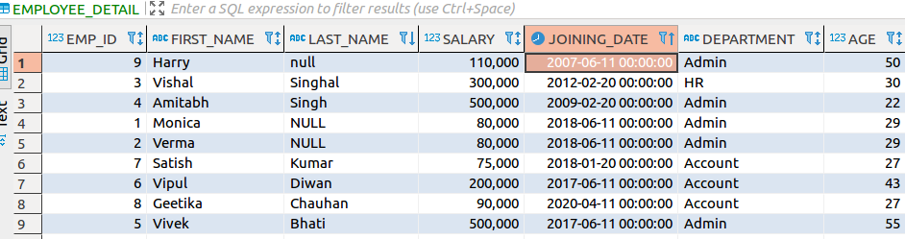

**4. Insert following data into table: EmployeeDetails**

**--EMP_ID FIRST_NAME LAST_NAME SALARY JOINING_DATE DEPARTMENT AGE**

**--10 Nithesh Pandey 100000 2014-02-20 IT Department 20**

--

INSERT INTO Employee_detail

(Emp_ID,First_Name,Last_Name,Salary,Joining_date,Department,Age) VALUES (10,'Nithesh', 'Pandey',100000, To_date('2020.02.14','yyyy.mm.dd'),'IT Department',20);

SQL Error [2290] [23000]: ORA-02290: check constraint (SYSTEM.SYS_C0011048) violated

**5)try to Insert following data into table: EmployeeDetails**

**EMP_ID FIRST_NAME LAST_NAME SALARY JOINING_DATE DEPARTMENT AGE**

**11 null Simha Reddy 9000 2020-02-20 Admin 22**

INSERT INTO Employee_detail

(Emp_ID,First_Name,Last_Name,Salary,Joining_date,Department,Age) VALUES (11,'Null', 'Simha Reddy',9000, To_date('2020.02.20','yyyy.mm.dd'),'Admin',22);

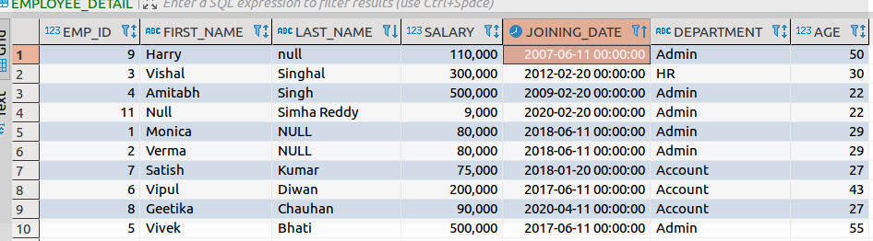

**5) create a table of name Bonus which is having columns: WORKER_REF_ID :Interger** **FOREIGN KEY, BONUS_AMOUNT :amount , BONUS_DATE: DATE**

CREATE TABLE Bonus

(Worker_Ref_Id INTEGER,

Bonus_Amount NUMBER(7,2),

Bonus_Date DATE,

CONSTRAINT fk_employee_detail FOREIGN KEY(Worker_Ref_Id) REFERENCES Employee_detail(EMP_ID));



**6) Insert following data into table: Bonus**

--WORKER_REF_ID BONUS_DATE BONUS_AMOUNT

--1 2016-02-20 5000

--2 2016-06-11 3000

--3 2016-02-20 4000

--1 2016-02-20 4500

--2 2016-06-11 3500

--

INSERT INTO Bonus (Worker_Ref_Id,Bonus_date,Bonus_amount)Values(1,To_Date('2016.02.20','yyyy.mm.dd'),5000);

INSERT INTO Bonus (Worker_Ref_Id,Bonus_date,Bonus_amount)Values(2,To_Date('2016.06.11','yyyy.mm.dd'),3000);

INSERT INTO Bonus (Worker_Ref_Id,Bonus_date,Bonus_amount)Values(3,To_Date('2016.02.20','yyyy.mm.dd'),4000);

INSERT INTO Bonus (Worker_Ref_Id,Bonus_date,Bonus_amount)Values(1,To_Date('2016.02.20','yyyy.mm.dd'),4500);

INSERT INTO Bonus (Worker_Ref_Id,Bonus_date,Bonus_amount)Values(2,To_Date('2016.06.11','yyyy.mm.dd'),3500);

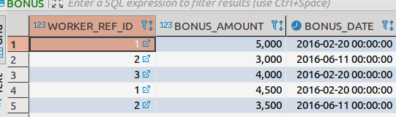

**7) create a table: Title of name which is having coloums: WORKER_REF_ID Integer and take as FOREIGN KEY, WORKER_TITLE varchar, AFFECTED_FROM date,**

CREATE TABLE TITLE

(Worker_Ref_ID integer,

worker_Title varchar(200),

Affected_from DATE,

CONSTRAINT fk_Bonus FOREIGN KEY(Worker_Ref_Id)REFERENCES Employee_detail(EMP_ID));

**8) Insert following data into table: Title**

--

--WORKER_REF_ID WORKER_TITLE AFFECTED_FROM

--1 Manager 2016-02-20

--2 Executive 2017-08-15

--8 Executive 2020-01-01

--5 Manager 2016-06-11

--4 Asst. Manager 2016-06-11

--7 Executive 2000-11-15

--6 Lead 2016-06-11

--3 Lead 2016-06-11

--

INSERT INTO TITLE(Worker_Ref_Id,Worker_Title,Affected_from)VALUES(1,'Manager',To_date('2016.02.20','yyyy.mm.dd'));

INSERT INTO TITLE(Worker_Ref_Id,Worker_Title,Affected_from)VALUES(2,'Executive',To_date('2017.08.15','yyyy.mm.dd'));

INSERT INTO TITLE(Worker_Ref_Id,Worker_Title,Affected_from)VALUES(8,'Manager',To_date('2020.01.01','yyyy.mm.dd'));

INSERT INTO TITLE(Worker_Ref_Id,Worker_Title,Affected_from)VALUES(5,'Manager',To_date('2016.06.11','yyyy.mm.dd'));

INSERT INTO TITLE(Worker_Ref_Id,Worker_Title,Affected_from)VALUES(4,'Asst.Manager',To_date('2016.06.11','yyyy.mm.dd'));

INSERT INTO TITLE(Worker_Ref_Id,Worker_Title,Affected_from)VALUES(7,'Executive',To_date('2000.11.15','yyyy.mm.dd'));

INSERT INTO TITLE(Worker_Ref_Id,Worker_Title,Affected_from)VALUES(6,'Lead',To_date('2016.06.11','yyyy.mm.dd'));

INSERT INTO TITLE(Worker_Ref_Id,Worker_Title,Affected_from)VALUES(3,'Lead',To_date('2016.06.11','yyyy.mm.dd'));

**9) Display all records from table: EmployeeDetails**

SELECT * FROM EMPLOYEE_DETAIL;

**10) Write a query to display firstname, lastname and department from EmployeeDetails.**

SELECT FIRST_NAME,LAST_NAME,DEPARTMENT FROM EMPLOYEE_DETAIL;

**11) update the table EmployeeDetails with LAST_NAME as nayak having Empployee id 5 .**

UPDATE EMPLOYEE_DETAIL SET LAST_NAME ='Nayak' WHERE EMP_ID = '5';

**12)Delete Employee record with having employee id as 9.**

DELETE EMPLOYEE_DETAIL WHERE EMP_ID = '9'

**13) update the date to today's date of Bonus table with id as 3.**

UPDATE Bonus SET date = '2020.05.18' WHERE Worker_Ref_Id = '3' (NOT UNDERSTOOD)

**14) Display all records from Title table.**

SELECT * FROM TITLE

**15 display all records from Bonus table.**

SELECT * FROM BONUS